***CODING CONTEST PAPER ( Himanshu Chadha B - 42 ) p-1***

# **Section A — Match the Column**

* A1→3
* A2→4
* A3→1
* A4→2
* A5→5

# **Section B — True / False**

1. Pandas DataFrames can only store integer data. — False
2. np.mean() returns the sum of an array. — False
3. In Python, if statements can be nested inside each other. — True
4. df.info() in pandas shows information about the DataFrame. — True
5. The result of 3 > 2 and 2 > 1 is True. — True

# **Section C — Fill in the blanks**

1. To create a NumPy array, we use np.array([1, 2, 3]).
2. To convert a string "15" to integer, use int("15").
3. The logical OR operator in Python is written as or.
4. To get the last 3 rows of a DataFrame df, use df.tail(3).
5. To add two numbers a and b, use the operator +.

# **Section D — Theory Questions**

1. **What is a DataFrame in pandas? Give a real-life example of where it can be used.**A DataFrame is a two-dimensional, tabular data structure in pandas with labeled rows and columns. It can store heterogeneous types (numbers, strings, dates) and supports indexing, filtering, grouping and aggregation. Real-life example: a sales spreadsheet with columns like Date, Product, Quantity, Price, used to analyze revenue, compute daily totals and generate sales reports.

***CODING CONTEST PAPER ( Himanshu Chadha B - 42 ) p-2***

**2. Explain the difference between if and elif in Python.**  
An if checks a condition and executes its block if the condition is true. An elif (else-if) provides additional conditions that are checked only when the preceding if (or previous elif) was false. We use elif to test multiple exclusive conditions in sequence, only the first true block runs.

**3. What is an aggregate function in NumPy? Name any two aggregate functions.**An aggregate function processes an entire array and returns a single summary value (e.g., sum, mean, min, max). Examples: np.mean() (average) and np.sum() (total sum).

**4. Why is type conversion important in Python? Give an example.**Type conversion allows converting values between types so operations behave correctly, for instance converting a numeric string to an integer before doing arithmetic. Example: int("10") + 5 converts the string "10" to the integer 10 so the sum equals 15, without conversion "10" + 5 would raise a TypeError.

**5. How can you inspect the structure of a DataFrame in pandas?**  
We can use df.info() to see column names, non-null counts and dtypes, and df.head() to preview the first rows. df.describe() gives summary statistics for numeric columns, df.shape shows number of rows and columns.

**Section E — Coding Questions**

### **Q1. Create NumPy array with values 1–10. Print mean, max, min.**

import numpy as np

arr = np.arange(1, 11)

mean_val = np.mean(arr)

max_val = np.max(arr)

min_val = np.min(arr)

print("Array:", arr)

print("Mean:", mean_val)

print("Max:", max_val)

print("Min:", min_val)

***CODING CONTEST PAPER ( Himanshu Chadha B - 42 ) p-3***

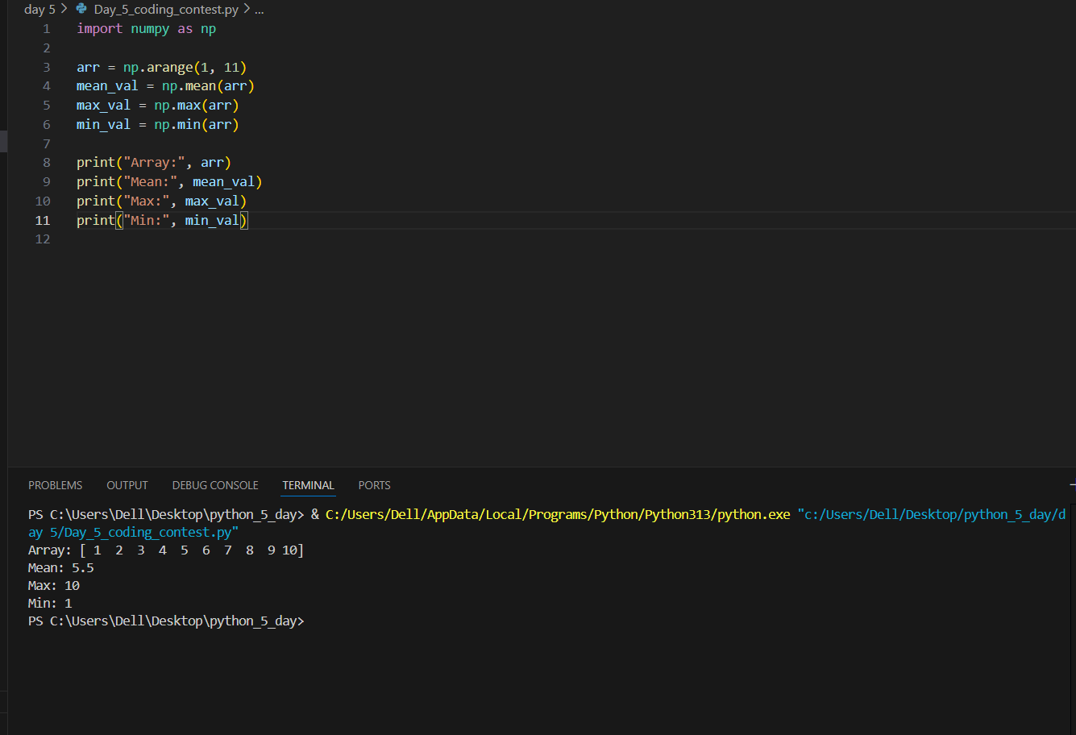

### **Q2. Input integer, print "Even" or "Odd".**

**n = int(input("Enter an integer: "))**

**if n % 2 == 0:**

**print("Even")**

**else:**

**print("Odd")**

***CODING CONTEST PAPER ( Himanshu Chadha B - 42 ) p-4***

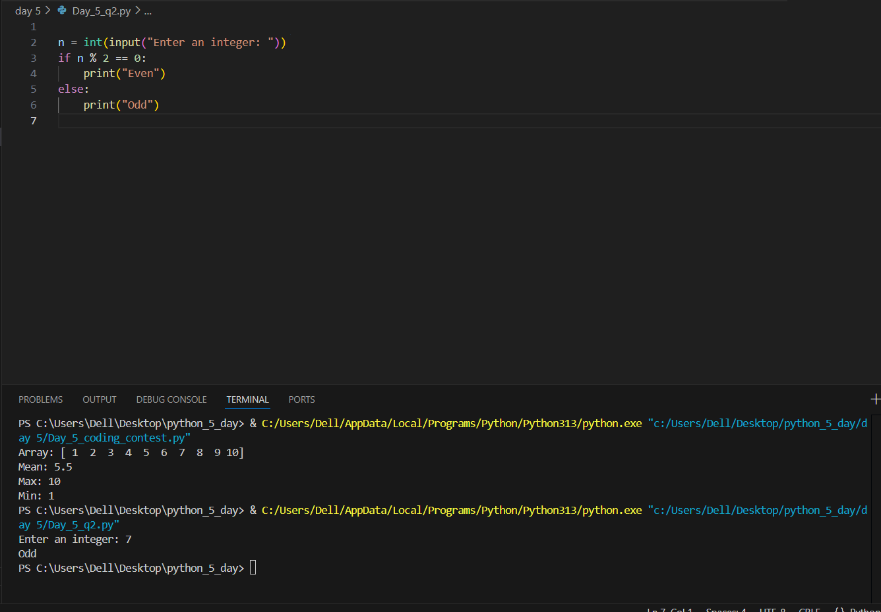

### **Q3. Create a pandas DataFrame with columns "Product" Rice, Sugar, Oil), and "Price" 50, 40, 100. Display the first row and use pandas to find the average price.**

import pandas as pd

data = {

"Product": ["Rice", "Sugar", "Oil"],

"Price": [50, 40, 100]

}

df = pd.DataFrame(data)

# Display first row

first_row = df.head(1)

# Average price

avg_price = df["Price"].mean()

print("First row:")

print(first_row)

print("\nAverage Price:", avg_price)

***CODING CONTEST PAPER ( Himanshu Chadha B - 42 ) p-5***

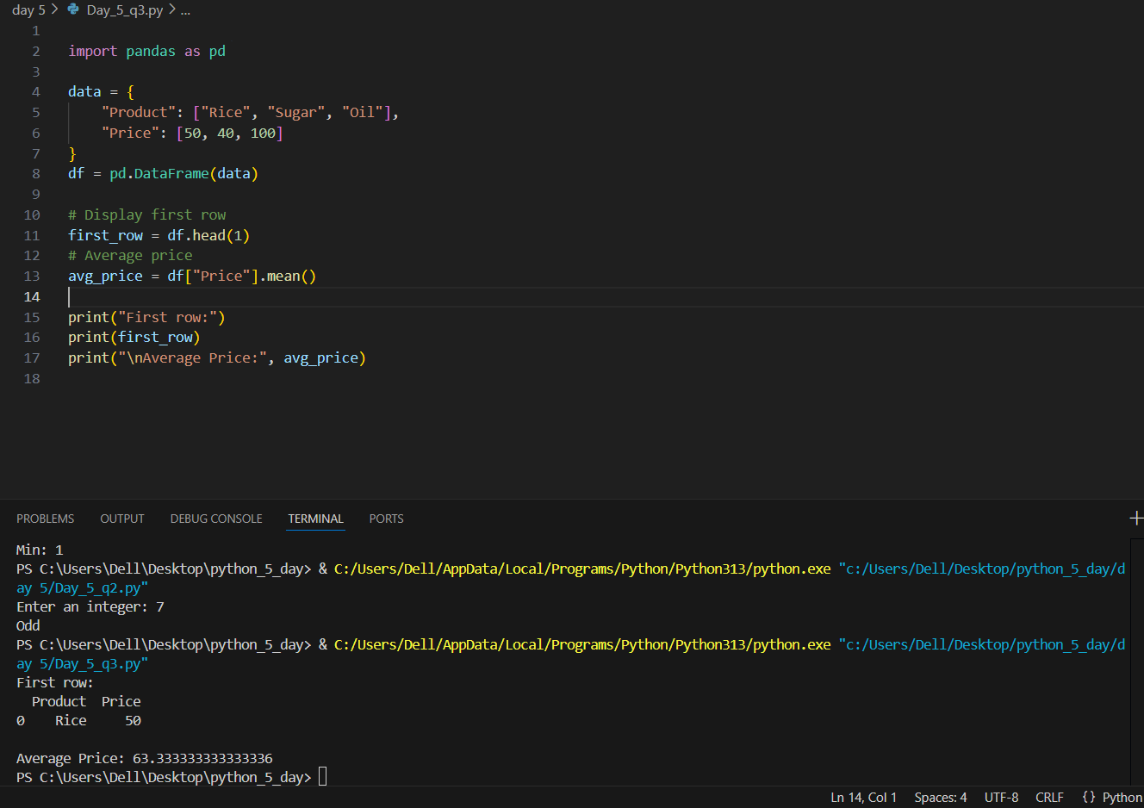

**Q4. Given a NumPy array arr = np.array([3, 8, 1, 6, 0, 7 , write code to count how many elements are greater than 4.**

**import numpy as np**

**arr = np.array([3, 8, 1, 6, 0, 7])**

**count_greater_4 = np.sum(arr > 4)**

**print("Array:", arr)**

**print("Count of elements > 4:", int(count_greater_4))**

***CODING CONTEST PAPER ( Himanshu Chadha B - 42 ) p-6***

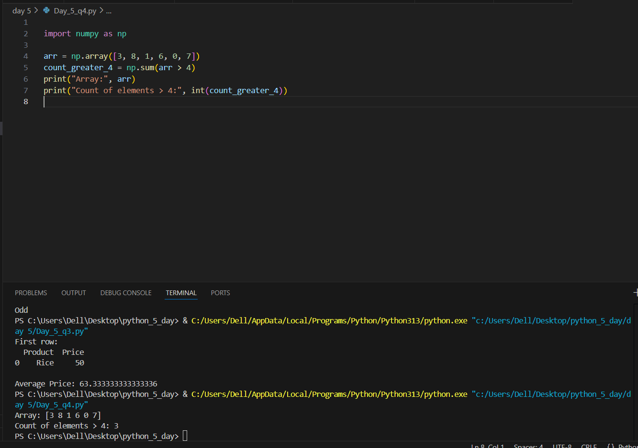

**Q5. Write Python code to check if a given number is positive, negative, or zero using if-elif-else statements. Print the result.**

**n = float(input("Enter a number: "))**

**if n > 0:**

**print("Positive")**

**elif n < 0:**

**print("Negative")**

**else:**

**print("Zero")**

***CODING CONTEST PAPER ( Himanshu Chadha B - 42 ) p-7***

